PEAK
Before You Read: Building Background Knowledge

Stage I - Meet the Author
Before you do anything with the novel, help get to know Roland Smith. It won’t take more than 30 minutes as he has an informative biography, pictures, and other interesting information right on his web site, www.rolandsmith.com

You can also email him questions.

- Where is Roland Smith originally from? ___________________________________________________ _____________________________________________________________________________________________________________________________________________________________________________

- Where does he live now and how does he spend his time? ___________________________________________________________________________________ _____________________________________________________________________________________________________________________________________________________________________________

- How many books has he written? ___________________________________________________ _____________________________________________________________________________________________________________________________________________________________________________

- Which of his books do you think might be the most interesting to read? Why? _____________________________________________________________________________________________________________________________________________________________________________

- Which of his no-fiction books do you think might be the most interesting to read? Why? _____________________________________________________________________________________________________________________________________________________________________________

- What is his novel PEAK about? _____________________________________________________________________________________________________________________________________________________________________________

Stage 2 – Meet the Geography: The majority of the book, Peak, will take place in Nepal. Study the maps, then answer the questions.
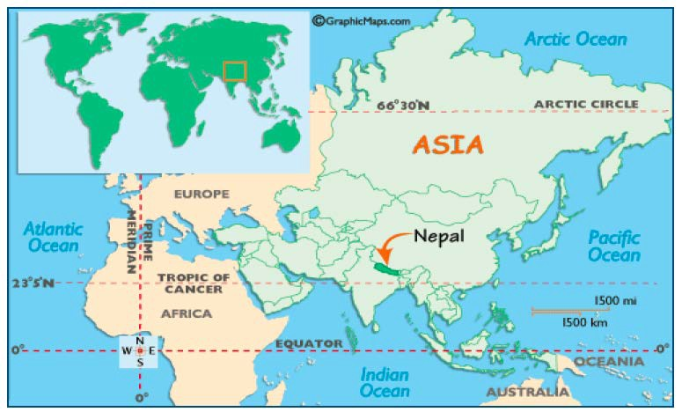
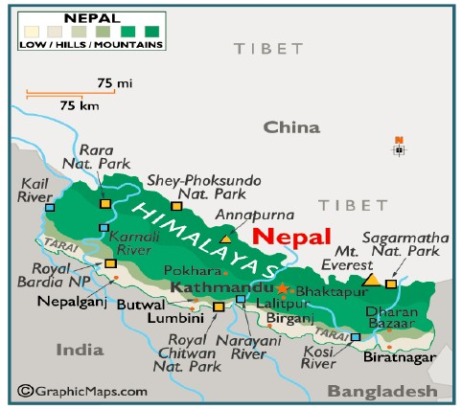
On which continent is Nepal located?

Which countries border Nepal?

What famous mountain is found in Nepal?

Stage 2 Meet Nepal: Use the "Facts and Photos" tab on the website below to answer the questions in complete sentences. - http://kids.nationalgeographic.com/kids/places/find/nepal/

- Which major mountain range can be found in Nepal?

- How was this mountain range formed?

- What natural resource is important to them? Why?

- How is deforestation affecting Nepal?

- Name the four animals that are endangered.

- What famous legend is said to be from Nepal?

- Name the two religions that most people practice.

- What are the four groups that make up the Nepalese population?

- What kind of government does Nepal have today?

- What languages are spoken in Nepal?

Stage 2 Meet the Flag: Use the website below to draw and color the Nepalese flag. (needs to be accurate and colored) http://kids.nationalgeographic.com/kids/places/find/nepal/

Stage 3 – Meet Mount Everest Vocabulary: Use the website below to find the word that matches each definition. Then, draw a small picture for each word.
http://teacher.scholastic.com/activities/hillary/archive/glossary.htm

A central setup of tents where food, equipment, and medical supplies are stored; a relay site for climbers. | The highest point. | A person who carries supplies.
A clan of people originally from Tibet who live along Nepal's mountainous eastern border with Tibet. | Height above sea level. | Metal frame with spikes worn on hiking boots for ice climbs.

Stage 4/Part 1 – Meet the Sherpas: Use the following websites to answer the questions in complete sentences. http://teacher.scholastic.com/activities/hillary/archive/sherpas.htm

- Why did the Sherpas move closer to Mount Everest?

- Why are Sherpas helpful in climbing expeditions?

- What fraction of the people who climb Mount Everest are Sherpas?

Stage 4/Part 2 – Meet Sir Edmund Hillary & Co. http://teacher.scholastic.com/activities/hillary/archive/evefacts.htm

- Where did Mount Everest get its name?

- How tall is it?

- Why is Mount Everest famous?

- Who were the first people to reach the summit of Mount Everest?

- How many people have successfully climbed Mount Everest?

Stage 4/Part 1 – Meet Jordan Romero
http://www.kidsnewsinc.com/index.php?option=com_content&view=article&id=96:jordan-romero- reaching-the-top-the-youngest-kid-to-climb-mount-everest

- Who was one of the youngest people to summit Mount Everest?

- How old was he?

- How did his lifestyle prepare him for climbing the mountain?

